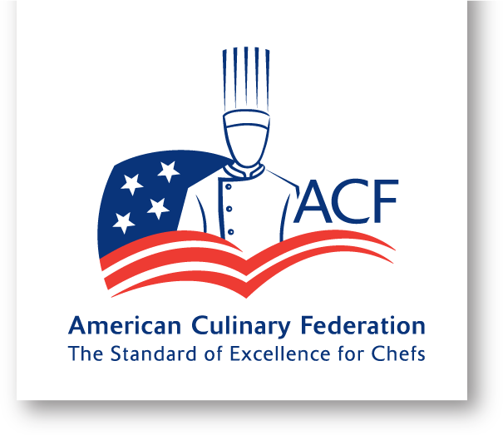

ACF Cape Cod & Islands Chef’s Association
Student Scholarship Application

Personal Information
Application Date: ___________________________
First Name: _________________________ MI: _____ Last Name: ___________________________
ACF member # ________________
Home Phone: _______________ Cell Phone: _____________________ Email: __________________
Home Address: ___________________________________________________________________
City: _________________________________ State: _________________ Zip: ________________

Education
Current School: ______________________________________________________________
Address: _________________________________________________________________________
City: __________________________________ State: ________________ Zip: ________________
Anticipated Graduation Date: ______________________ Current GPA:______________

Post-Secondary Education
Educational Institution: ______________________________________________________________
Address: _________________________________________________________________________
City: __________________________________ State: ________________ Zip: ________________
Degree Pursued: ___________________________________________________________________ Date of Enrollment: _________________ Anticipated Graduation Date: ______________________

Industry Experience (include current and previous employment and apprenticeship opportunities)
Employer | Position | Supervisor | Length of Employment

References (include 3 references)
Name | Position/Title | Contact Information | Relationship

Participation in culinary events
Activity: _______________________________________________ Date: ___________________
Activity: ________________________________________________ Date: ___________________
Activity: ________________________________________________ Date: ___________________

Volunteer for school or industry activities
Activity: _______________________________________________ Date: ___________________
Activity: ________________________________________________ Date: ___________________
Activity: ________________________________________________ Date: ___________________

American Culinary Federation activities
Event/Activity: _________________________________________ Date: _____________________
Event/Activity: _________________________________________ Date: _____________________
Event/Activity: _________________________________________ Date: _____________________

Question 1: Explain why you would be a good candidate for this scholarship.

Question 2: What do you hope to contribute to the culinary industry?

Question 3: Describe the importance and benefits of becoming a member of a professional organization?

Question 4: Describe how important community service is to you?

Question 5: How are you planning on furthering your education after graduation?

Applicant Signature: ________________________________________ Date: ______________________

Application Deadline: May 1, 2024

Please forward applications to Dan Ferrare CEC, CCA by deadline via mail or email:
ACF Cape Cod & Islands Chef’s Association
C/O Dan Ferrare
267 Wood St.
Middleboro, MA 02346
Or
danielferrare@comcast.net

